This assignment has three parts.
Part One: Programming
Write a program to move the Turtle based on the user’s request. Display a menu with options for the user to choose. Use the following guidelines to write your program.

- Create a menu that gives the user options for moving the Turtle. The menu should contain letters or numbers that align with movements such as forward, backward, and/or drawing a particular pattern.
- Use at least one if-else or elif statement in this program. It should be used to move the Turtle based on the user's input.
- A loop is optional but may be used to ask the user to select multiple choices.
- Use one color other than black.
- Write the pseudocode for this program. Be sure to include any needed input, calculations, and output.
Insert your pseudocode here:
INPUT | Input S to draw a Square  Input R to draw a Rectangle  Input C to draw a Circle  Input T to draw a Triangle  Input Q to Quit
OUTPUT | Input S – Draw Square
OUTPUT | Input R – Draw Rectangle
OUTPUT | Input C – Draw Circle
OUTPUT | Input T – Draw Triangle
OUTPUT | Input Q – Quit and Close Turtle Window

Part Two: Code the program.
Use the following guidelines to code your program.

- To code the program, use the Python IDLE.
- Using comments, type a heading that includes your name, today’s date, and a short description of the program.
- Follow the Python style conventions regarding indentation and the use of white space to improve readability.
- Use meaningful variable names.

Example of expected output: The screen shot below is an example of a menu. Your specific results will vary depending on the choices you make. This sample moves the turtle forward, backward, left, or right based on user input of F, B, L, or R, which are the menu options. The user inputs Q to quit.

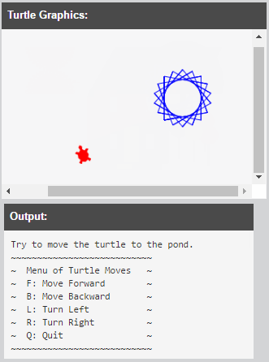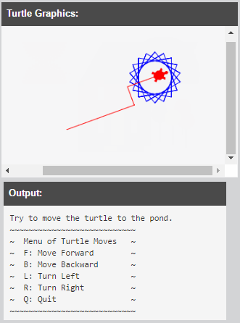

Insert your program code here:
# Shashank Navale
# 08/09/2020
# Purpose: The purpose of the program is to allow the user to control the movements of the turtle, using the turtle module

import turtle # imports turtle module

def square(shashank): # defines new function called square
shashank.color("green yellow") # sets turtle color to Green Yellow
for n in range(0, 4): # loop code 4 times
shashank.forward(100) # Forward turtle by 100 units
shashank.left(90) # Turn turtle by 90 degree
turtle.done() # keeps the turtle window open

def rectangle(shashank): # defines new function called rectangle
shashank.color("blue") # sets turtle color to blue
shashank.forward(300) # forward turtle by 300 units
shashank.left(90) # turns left by 90 degrees
shashank.forward(200) # forward turtle by 200 units
shashank.left(90) # turns left by 90 degrees
shashank.forward(300) # forward turtle by 300 units
shashank.left(90) # turns left by 90 degrees
shashank.forward(200) # forward turtle by 200 units
shashank.left(90) # turns left by 90 degrees
turtle.done()

def circle(shashank): # defines new function called circle
shashank.color("red") # sets turtle color to red
shashank.circle(50) # circle turtle by radius of 50
turtle.done() # keeps the turtle window open

def triangle(shashank): # defines new function called triangle
shashank.color("green") # sets turtle color to green
shashank.forward(100) # turtle forward by 100
shashank.left(120) # turtle left by 120
shashank.forward(100) # turtle forward by 100
shashank.left(120) # turtle left by 120
shashank.forward(100) # turtle forward by 100
shashank.left(120) # turtle left by 120
turtle.done()

def main(): # defines the main function
shashank = turtle.Turtle() # names the turtle "Shashank"
shashank.setpos(0, 0) # sets teh turtle position to 0, 0
shashank.speed(1) # sets turtle speed to 1
shashank.shape("turtle") # sets turtle shape to "Turtle"

# prints the following instructions for the user
print("~~~~~~~~~~~~~~~~~~~~~~~~~~~~~~~~~~~~~~~~~~~~~~~~~~~")
print("Please enter the following Input Values as desired")
print("Input S to draw a Square")
print("Input R to draw a Rectangle")
print("Input C to draw a Circle")
print("Input T to draw a Triangle")
print("Input Q to Quit")
print("~~~~~~~~~~~~~~~~~~~~~~~~~~~~~~~~~~~~~~~~~~~~~~~~~~~")

userInput = input("Input Value to Move Turtle (Read Instructions above)") # asks for user input with the following message
if(userInput == "S"): # checks if the user input equals S
square(shashank) # if yes, runs the square function
elif(userInput == "R"): # checks if the user input equals R
rectangle(shashank) # if yes, runs the rectangle function

if(userInput == "C"): # checks if the user input equals C
circle(shashank) # if yes, runs the circle function
elif(userInput == "T"): # checks if the user input equals T
triangle(shashank) # if yes, runs the triangle function

if(userInput == "Q"): # checks if the user input equals Q
turtle.bye() # if yes, quits and closes the Turtle Graphics Window

main() # ends the program

Part Three: Post Mortem Review
Complete the Post Mortem Review (PMR). Write thoughtful two to three sentence responses to all the questions in the PMR chart.
Review Question | Response
What was the purpose of your program? | The purpose of the program is to draw shapes based on user input
How could your program be useful in the real world? | This program can be very useful in the educational field. Kids can learn to identify shapes all along with learning how to use technology.
What is a problem you ran into, and how did you fix it? | I didn’t run into many problems however I kept missing the colon towards the end of the El-If statements and python sent me a lot of errors
Describe one thing you would do differently the next time you write a program. | One thing I would do different next time will be that I will remember to include the colons after the else or else if statements since they were a problem this time

